GParted exercises

**For the following exercises, you have to use a Windows 7 or 10 virtual machine. To solve the exercises, create a document with screenshots including the settings for each part.**

# Exercise 1

First, let us create a new hard disk for the virtual machine. Then, we are going to create the following partitions:

* A NTFS primary partition of 2GB called PNTFS.
* An EXT4 primary partition of 2GB called PEXT4.
* An extended partition of 4GB.
* A logical partition of 2GB called PFAT32.

Now open Disk Management in Windows. You should have a configuration just like in the picture below.

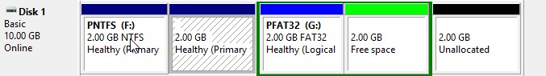

Answer the following questions

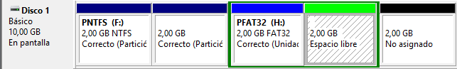

1. Why is the file system not showed in the second partition?

Because windows does not recognize ext4 file sistem.

1. If you had to create a new partition to store 2 GB data, where would you put the partition in? Which file system should you use? Justify your answer.

We can only use the last bit of the sectors of the disk, as are the only sectors free. I would use ntfs file system as we are going to be sing windows.

# Exercise 2

Create a new disk of 5GB in the same Windows virtual machine. Now, configure the partitions with GParted to get the following result:

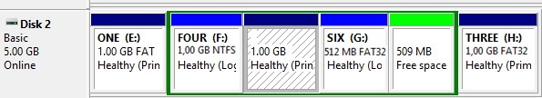

Answer the following questions

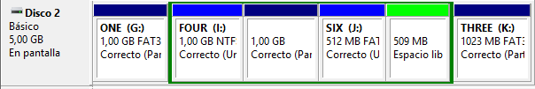

1. How does GParted name the new hard disk?

In my case, Linux named the third disk sdc

1. List all the partitions you have created, indicating type and file system.

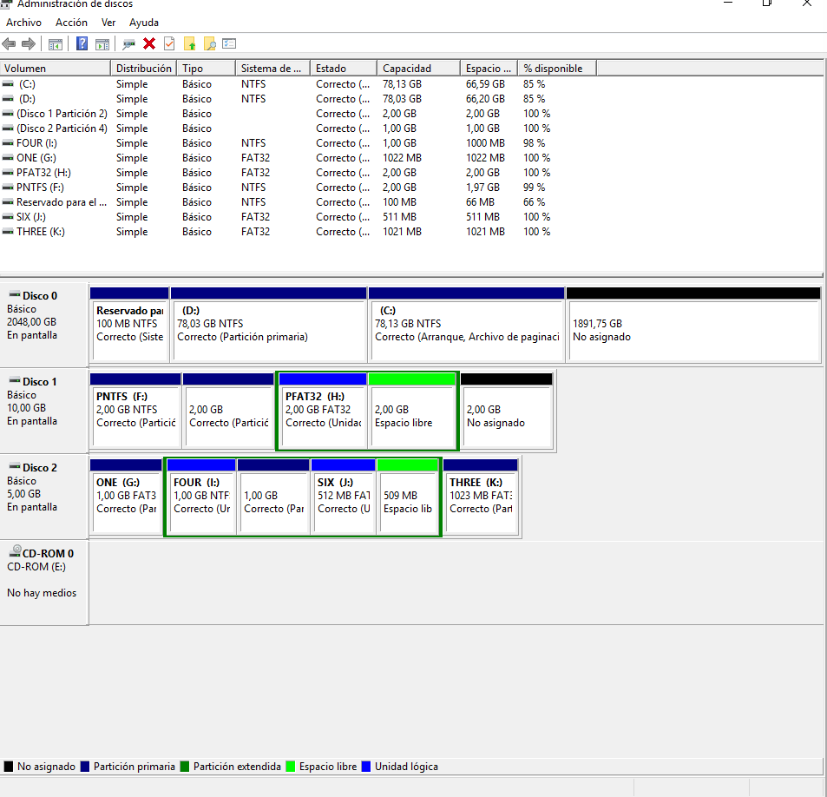

1